How to create or update your email signature in Outlook:

Note: When you open the signature template, it may open in Word in Protected View. To edit the template, you'll need to select Enable Editing.

Step 1: Click on the text in the appropriate sample email signature below and enter your contact information to replace placeholder text.

Note: If you are using the SRPM Site Team email signature, to update your community website, highlight your community website, right-click, select 🔗Link, and a box will appear. In the Text to display box, enter your community’s name, and in the Address box, add your community website link.

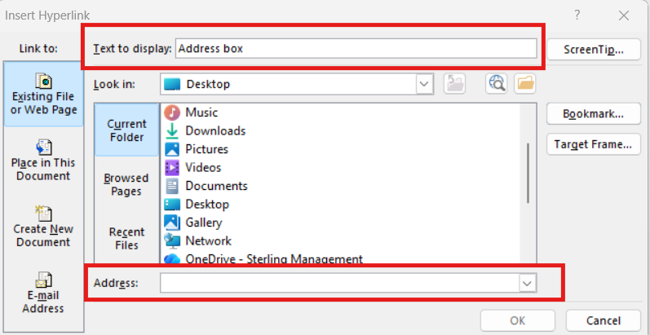

SRC:
Your First and Last Name
Your Title

O: 000-000-000
C: 000-000-000
www.stonerivercompany.com


SRPM:
Your First and Last Name
Your Title

O: 000-000-000
C: 000-000-000
www.stoneriverpm.com


SRPM SITE TEAMS:
Your First and Last Name
Your Title | Your Community
Community Address
City, State Zip

P: 000-000-000
your community website

Step 2: Hover over the signature, then click  to select the elements in the signature.

Step 3: Right-click and select Copy or (Ctrl + C).

If you have the Classic Outlook Program, continue use the steps under the Classic Outlook header below. If you have upgraded to the new Outlook, then skip ahead to new Outlook.

Classic Outlook:

Classic Step 1: Open Outlook and select File from the top bar.

Classic Step 2: Open Options at the bottom of your screen and then select Mail.

Classic Step 3: Select the Signatures button.

Classic Step 4: Select New, enter a name for your signature (this can be whatever you like), then select OK.

Note: If you are replacing a signature already created, simply select the signature to edit, highlight the text in the edit signature text box, and delete all text. (Make sure to delete all text before pasting new text.)

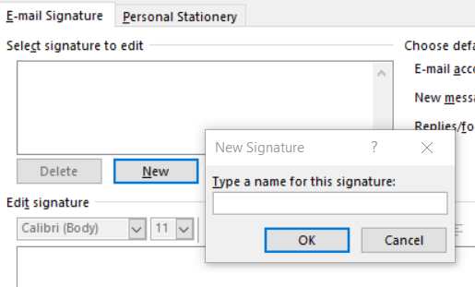

Classic Step 5: Click inside the edit signature text box and Paste (Ctrl + V) the signature in the email body.

Classic Step 6: Under Choose default signature, use the dropdown option to select the new signature you just created for New messages and Replies/forwards.

Classic Step 7: Select OK to save and close the signature box. Then select OK again to close the Outlook options box.

New Outlook:

New Step 1: Open Outlook and select File from the top bar.

New Step 2: Open Settings from the dropdown menu and then select Accounts in the left-side column.

New Step 3: Select the Signatures option.

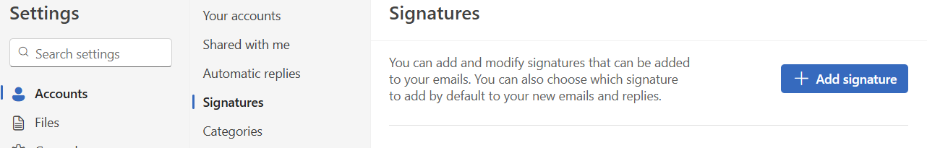

New Step 4: Select + Add signature, enter a name for your signature (this can be whatever you like), then click below in the signature text box and Paste (Ctrl + V) the signature in the email body.

Note: If you are replacing a signature already created, simply select the signature to edit, highlight the text in the edit signature text box, and delete all text. (Make sure to delete all text before pasting new text.)

New Step 5: Make sure to check the boxes to “Set default for new messages” and Set default for replies and forwards.”

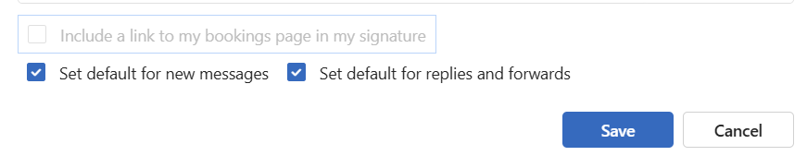

New Step 6: Select SAVE to close the signature box.

